Manuscript Title in Title Case
(Each Word of the Title Should be Capitalised)
Presenting Author (Name & Family name)
Organisation
Address
ZIP Code, City, Country
author.one@email.com
Other Authors (Name & Family name) – if more separate with commas
Organisation
Address
ZIP Code, City, Country
author.two@email.com, author.three@email.com

ABSTRACT
This file provides a template for writing papers for the conference. The conference proceedings will be published in an electronic format. The manuscript shall be written in compliance with these instructions.

INTRODUCTION
It is expected that the authors will submit carefully written and proofread material. Spelling and grammatical errors, as well as language usage problems, are not acceptable. The authors should limit their papers to 8 pages, presenting their results as concisely as possible.

PAPER FORMAT
The uniform outlook will help the reader to follow the proceedings. This can be obtained most easily if the authors use this template file to construct their manuscripts. Please note the following details: this template is an A4 format with 25 mm margins on the left, right, top and bottom.
All text paragraphs should be single spaced; with the first line indented for 10 mm. The position and style of headings and subheadings should follow this example. No spaces should be placed between paragraphs or headings and paragraphs. All format styles are predefined (all have names starting with S, following a two digit number) and available in the menu Styles.

Header, Footer, Page Numbering
If this template is used when writing the manuscript, the headers and footers will be set automatically. The authors are only asked to replace the "NNN" with their paper number on the footer of the first page and on the header of other pages in order to set a unique page number in the Proceedings. The paper number is written on your letter of acceptance or can be obtained from the web site of the conference (www.djs.si/nene2023/) in the Conference Program section.

Fonts
The papers should use 11-point Arial or equivalent. Arial, Symbol or Times New Roman fonts can be used in figures. It is recommended that the text in figures is not smaller than 10-point font size. The authors are discouraged from using other fonts.

Figures and Tables
The figure captions and table headings should be sufficient to explain the figure or table without needing to refer to the text. Figures and tables not cited in the text should not be presented.
Table 1: Example table
Important dates
August 31, 2023 | Full length papers
November 15, 2023 | Proceedings

The tables and figures should be placed close after the paragraph of their first mentioning. All figures and tables shall be numbered with Arabic numerals. The table headings shall be centred above the tables. The figure captions should be centred below the figures.
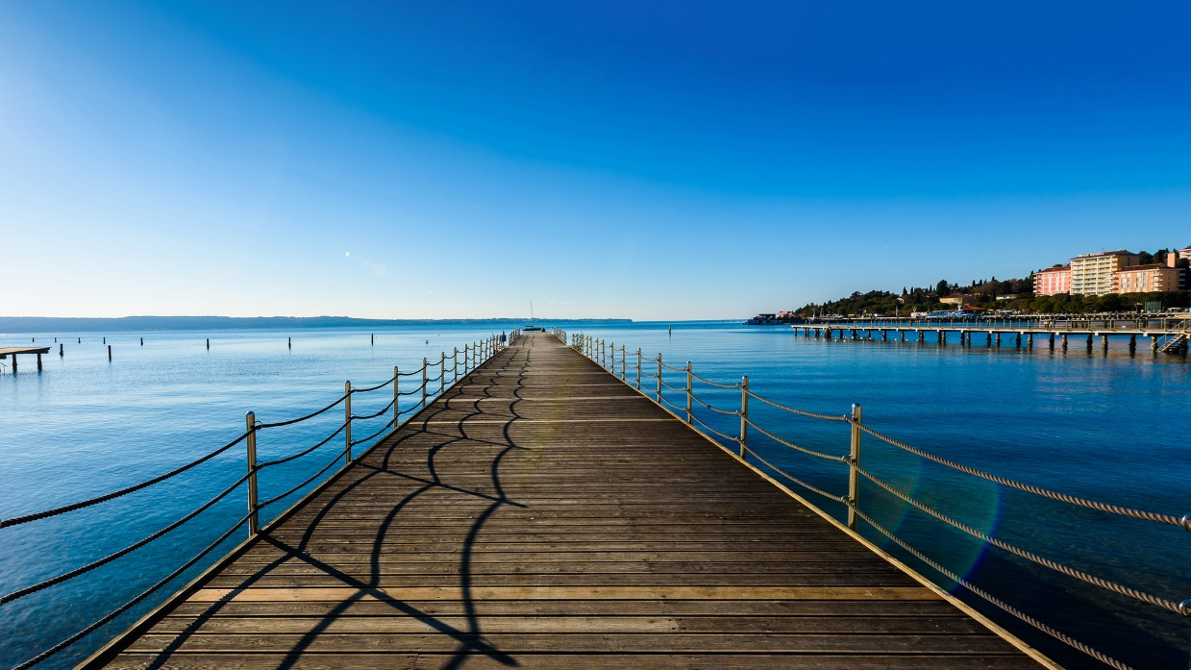
Figure 1: Example figure – Grand hotel Bernardin
Please use “In Line with Text” text wrapping for figures – click the image, then click the Picture Tools Formatting tab. In the Text Wrapping menu choose In line with Text.

Equations
Each equation should be presented on a separate line with a blank space above and below. The equations should be numbered consecutively at the outer right margin, as shown in Eq. (1) below.
(1)

References
Reference numbers in the text should be designated by square brackets, e.g., [1]. The references should be listed in the same order as cited in the text. Some examples of how to list references are given in the Section References.

Submitting the Manuscript
The MS Word manuscripts should be submitted as a .doc or .docx file electronically through the conference website www.djs.si/nene2023/ before August 31, 2023. The same account as used for the submittal of the abstract should be used for the submission of the paper. Please login and upload the paper in the My Abstracts and Papers tab.

ACKNOWLEDGMENTS
The organizer gratefully acknowledges the work done by all Organizing Committees of the International Conferences Nuclear Energy for New Europe who prepared the first and the improved versions of the template.

REFERENCES
- H. L. Langhaar, S. C. Chu, Development in Theoretical and Applied Mechanics, Pergamon, New York, 1970, pp. 84-100. (for a book)
- T. V. Vo, D. R. Edwards, "Development of In-Service Inspection Priorities for PWR", Nucl. Technol., 106, 1994, pp. 253-259. (for a paper in a journal)
- J. E. Dendy Jr., B. Swartz, B. Wendroff, "Computing travelling wave solutions of a nonlinear heat equation". In: J. J. H. Miller, (Ed.), Topics in Numerical Analysis, Vol. III, Academic Press, London, 1977, pp. 447-463. (for a paper in a contributed volume)
- R. Baltus, A. Rubbers, "Piping reliability improvement through passive seismic supports", Proc. Int. Conf. Nuclear Energy in Central Europe '99, Portorož, Slovenia, September 6-9, Nuclear Society of Slovenia, 1999, pp. 251-258. (for a paper in the proceedings)

